**Project Design Phase-II**

**Technology Stack (Architecture & Stack)**

|  |  |
| --- | --- |
| Date | 15 October 2022 |
| Team ID | PNT2022TMID33827 |
| Project Name | Smart Farmer – IoT Enabled Smart Farming Application |
| Maximum Marks | 4 Marks |

**Technical Architecture:**

The Deliverable shall include the architectural diagram as below and the information as per the table1 & table 2

Guidelines:

1. Include all the processes (As an application logic / Technology Block)
2. Provide infrastructural demarcation (Local / Cloud)
3. Indicate external interfaces (third party API’s etc.)
4. Indicate Data Storage components / services
5. Indicate interface to machine learning models (if applicable)

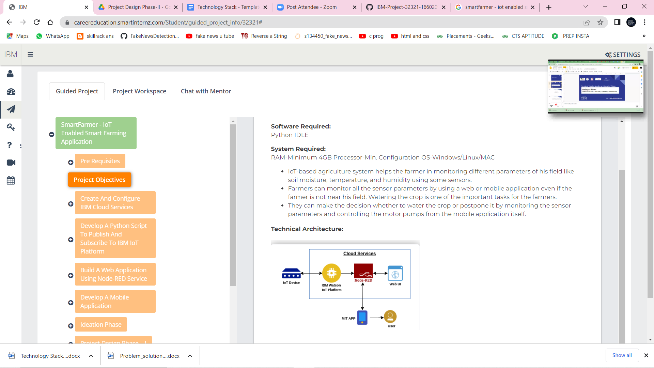

**Table-1 : Components & Technologies:**

|  |  |  |  |
| --- | --- | --- | --- |
| **S.No** | **Component** | **Description** | **Technology** |
|  | User Interface | Web UI, Node-RED, MIT app | IBM IoT Platform, IBM Node red, IBM Cloud |
|  | Application Logic-1 | Create Ibm Watson IoT platform and create node-red service | Ibm Watson, ibm cloudant service,ibm node-red |
|  | Application Logic-2 | Develop python script to publish and subscribe to IBM IoT Platform | python |
|  | Application Logic-3 | Build a web application using node-red service | IBM Node-red |
|  | Database | Data Type, Configurations etc. | MySQL |
|  | Cloud Database | Database Service on Cloud | IBM DB2, IBM Cloudant |
|  | File Storage | Developing mobile application to store and receive the sensors information and to react accordingly | Web UI,python |
|  | External API-1 | Using this IBM Weather API we can track the weather in the agriculture land and based on the weather reading the sensors will activate | IBM Weather API |
|  | External API-2 | Using this IBM Sensors it detects the weather, humidity, soil fertility and provides the activation of motors to web UI | IBM Sensors |
|  | Machine Learning Model | Using this we can derive the object recognition model | Object Recognition Model |
|  | Infrastructure (Server / Cloud) | Application Deployment on Local System / Cloud  Cloud Server Configuration | IBM cloudant, IBM IoT Platform |

**Table-2: Application Characteristics:**

| **S.No** | **Characteristics** | **Description** | **Technology** |
| --- | --- | --- | --- |
|  | Open-Source Frameworks | MIT app Inventor | MIT License |
|  | Security Implementations | IBM Services | Encryptions, IBM Controls |
|  | Scalable Architecture | sensor-IoT Cloud based architecture | cloud computing and AI |
|  | Availability | Mobile, laptop, desktop | MIT app |
|  | Performance | Detects the water level, soil growth, humidity, weather | sensors |